PAPER TITLE [Arial 14, bold, centred, Upper Case]
Author Name¹, Author Name² [Arial, 12-point, bold, centred]
¹Author Affiliation (COUNTRY) [11-point, italic, centred]
²Author Affiliation (COUNTRY) [11-point, italic, centred]

Abstract [Arial, 12-point, bold, centred]
This template will assist you in formatting your paper. Please, copy it on your computer and insert the text keeping the format and styles indicated. The various components of your paper (title, abstract, keywords, sections, text, etc.) are already defined on the style sheet, as illustrated by the portions given in this document. [Arial, 10-point, justified alignment]. Abstract consists of maximum 250 words.
Keywords: Innovation, technology, research projects, etc. [Arial 10-point, justified alignment]. [Maximum 5 words]

INTRODUCTION [Arial, 12-point, bold, upper case and left alig.]
The final paper length should be between 4 to 10 pages (including references). All pages size should be A4 (21 x 29,7cm). The top, bottom, right, and left margins should be 2,5 cm. All the text must be in one column and Arial font, including figures and tables, with single-spaced 10-point interline spacing. [Arial, 10 point, normal, justified alignment]

METHODOLOGY
A paper should contain the description of your study and should be structured in different sections such as: Abstract, Introduction, Methodology, Results, Conclusions, Acknowledgements (if applicable) and References. Please note that title and authors list should be coincident with the accepted abstract.

RESULTS
The text included in the sections or subsections must begin one line after the section or subsection title. Do not use hard tabs and limit the use of hard returns to one return at the end of a paragraph.

Subsection [Arial 12, bold, left alignment and capitalize the first letter]
Please, do not number manually the sections and subsections; the template will do it automatically.

Sub-subsection: Guidelines for Abbreviations and Acronyms
Define abbreviations and acronyms the first time they are used in the text, even after they have been defined in the abstract. Do not use abbreviations in the title or heads unless they are unavoidable.

Sub-subsection: Guidelines for Figures and Tables
Tables and figures should be centred and are numbered independently, in the sequence in which you refer to them in the text. Use the abbreviation “Figure. 1”, even at the beginning of a sentence. Figure captions should be below figures and graphics should be accompanied by a legend; table heads should appear above tables.
Table 1. Caption for the table.
 | Heading 1 | Heading 2 | Heading 3
One | 1 | 2 | 3
Two | 4 | 5 | 6
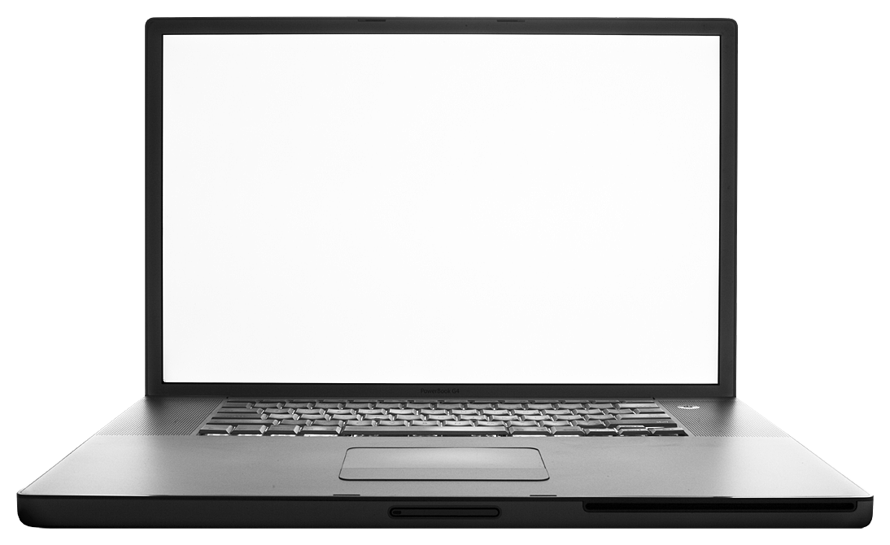
Figure 1. Caption for the figure.

Sub-subsection: Guidelines for Page numbers and Footnotes
Please, do not add any kind of pagination anywhere in the paper. Avoid using headers and footnotes.

Sub-subsection: Guidelines for References
The list of the references should be given at the end of the paper. References are numbered in brackets by order of appearance in the document (e.g. [1], [2], [3]). The same reference can be cited more than once in the text with the same reference number. The references should be cited according to the Bibliography and Citation Style: https://iated.org/citation_guide.

CONCLUSIONS
Use as many sections/subsections as you need.
ACKNOWLEDGEMENTS [Arial, 12-point, bold, left alignment]
Optional statement to thank other contributors, assistance, or financial support.
REFERENCES [Arial, 12-point, bold, left alignment]
References [Arial, 10-point, left alignment, upper and lower case] should be cited according to the Bibliography and Citation Style https://iated.org/citation_guide
- A. Einstein, “General theory of relativity,” Annalen der Physik, vol. 49, no. 7, pp. 769–822, 1916.
- A.A. Author, "Journal/Conference Article Title," Periodical Title, vol. Volume, no. Issue, pp.-pp., Publication Year.
- A.A. Author, Book Title. City/State: Publisher, Year of Publication.
- A.A. Author, "Chapter Title" in Book Title (Editors eds.), pp.-pp., City/State: Publisher, Year of Publication.
- A.A. Author, "Online Article Title," Periodical Title, vol. Volume, no. Issue, pp.-pp., Publication Year. Retrieved from URL.

